**A**

**Practical Assignment**

**On**

**New Age Life Skills**

Bachelor of Technology in Computer Science

1st SEM



**RUNGTA INTERNATIONAL SKILLS UNIVERSITY**

SESSION: 2025-26

Ms. Harshali Vaishnaw Submitted by: Megha Band

(Lecturer) Ref No. :

**Submitted To:**

**RUNGTA INTERNATIONAL SKILLS UNIVERSITY, CG**

**SCHOOL OF COMPUTER SCIENCE & TECHNOLOGY**

|  |  |  |  |
| --- | --- | --- | --- |
| **S.No** | **Name Of Practical**  **INDEX** | **Submission Date** | **Remark** |
| **1.** | **Design a professional resume using templates.** | **22-09-2025** |  |
| **2.** | **Create a Career Oriented Presentation with 7 slides using transitions and animations.** | **29-09-2025** |  |
| **3.** | **Create a social media poster for “DIGITAL AWARENESS WEEK” using canva.** | **01-10-2025** |  |
| **4.** | **Compose & send a professional email with an attachment as “you are applying for an internship, send email to HR with your resume attached”.** | **06-10-2025** |  |
| **5.** | **Design a complete Google Form survey and analyze responses.**   1. **Create a Google Form titled “Student Attendance Report”.** 2. **Include the following question types:**    1. **5 MCQs**    2. **1 Rating scale (1–5)**    3. **1 Short answer**    4. **1 Checkbox question** 3. **Customize the theme (header image + color).** 4. **Share the form link with 5 friends and collect responses.** 5. **Generate charts from responses and take screenshots of the analysis page.** | **11-10-2025** |  |
| **6.** | **Demonstrate the creation and management of your digital identity.**   1. **Create a social media profile (LinkedIn preferred).** 2. **Add a profile photo, short bio, skills, and education details.** 3. **Create a simple post about “My Learning Journey in Digital Literacy.”** 4. **Change your privacy settings to:**    1. **Who can see your posts.**    2. **Who can message you** | **31-10-2025** |  |
| **7.** | **Using Google Drive or OneDrive:**   1. **Create a new folder named “Unit 3 Practical Work”.** 2. **Upload 3 different files (PDF, image, document).** 3. **Organize them in subfolders: Notes, Images, Assignments.** 4. **Share the main folder with your teacher with View Only permission.** | **13-11-2025** |  |
| **8.** | **Identify one real phishing email : A final-year student, Aman, receives a LinkedIn message saying:**  **“You are shortlisted for a Remote Software Developer role at Google.**  **Salary: ₹18 LPA.**  **Pay ₹2,499 as verification fee.**  **Limited seats. Pay now to confirm.”**  **ANSWER THE QUESTIONS :-**   1. **What type of cybercrime is happening here?** 2. **List 3 red flags that show it is a scam?** 3. **What should he do to verify if a job offer is real?** | **19-11-2025** |  |
| **9.** | **Create a Google Form Quiz with the following requirements:**   1. **Convert the form into a Quiz mode with automatic grading.** 2. **Add 5 MCQ questions, each carrying 2 marks.** 3. **Add 1 short answer question that requires manual evaluation.** 4. **Turn ON the setting:**    1. ***Limit to 1 response***    2. ***Shuffle question order***    3. ***Release marks after manual review*** 5. **Add a timer add-on (like form presenter) and set up a 10-minute time limit.** 6. **Finally, send the quiz link and view the response summary.** | **24-11-2025** |  |
| **10.** | **Ask ChatGPT OR Google Gemini to generate a 100–120 word paragraph on:**  **“Is online learning better than offline learning for college students?”**   * + 1. **Run the AI-generated text through Grammarly and any plagiarism-check tool.**     2. **Now manually search online to check if similar sentences exist on blogs or articles.**     3. **Identify 2–3 biased statements in the AI answer, such as:**        - 1. **Over-generalizations**          2. **One-sided opinions**          3. **Unproven claims**     4. **Rewrite the entire paragraph in a neutral and balanced way, using AI only for grammar suggestions.**     5. **Submit 3 screenshots:**  1. **Plagiarism check result** 2. **Grammarly suggestion page** 3. **Original AI paragraph vs your rewritten unbiased version** | **29-11-2025** |  |
| **11.** | **To compare AI-generated content with student-created content and understand limitations of AI.**   1. **Write a 100–150 word paragraph on the topic: “Will AI replace jobs or change them?” (This must be written by the student.)** 2. **Ask any AI tool (ChatGPT/Gemini/Copilot) to write the same topic.** 3. **In your practical copy, create a Comparison Table with the headings:** 4. **Human-Generated Content** 5. **AI-Generated Content** | **03-12-2025** |  |
| **12.** | **Create a new NotebookLM project titled: “My Chapter Revision Notes.”**   1. **Upload multiple sources (any 2) such as:**    * 1. **PDF notes**      2. **Web articles**      3. **Text copied into NotebookLM** 2. **Ask NotebookLM to:**    * 1. **Create a combined study guide using all sources.**      2. **Generate flashcards for quick revision.**      3. **Create a concept map or explanation of the topic.** 3. **Manually check for:**    * 1. **Any incorrect facts**      2. **Repeated information**      3. **Missing important points** 4. **Attach 3 screenshots from NotebookLM:**    * 1. **Combined study guide**      2. **Flashcards**      3. **Concept map / explanation** | **10-12-2025** |  |
| **13.** | 1. **Create a complete Student Result Management workbook.** 2. **Create a new workbook with 3 sheets renamed as:**    1. ***Student_Data***    2. ***Marks_Analysis***    3. ***Charts*** 3. **In *Student_Data*, enter a list of 15 students with: Name, Roll No, Class, City, Subject1, Subject2, Subject3.** 4. **Use Flash Fill to split “Full Name” into “First Name” and “Last Name”.** 5. **Use Find & Replace to replace city name “Delhii” with correct “Delhi”.** 6. **Use IF function to calculate Pass/Fail (Pass = total ≥ 120).** 7. **Use COUNTIF to find how many students belong to “Delhi”.** 8. **Use AVERAGE, MAX, MIN to analyze marks in the *Marks_Analysis* sheet.** 9. **On the *Charts* sheet, create:**    * 1. **A Bar Chart showing marks of any one subject.**      2. **A Pie Chart showing percentage of pass vs fail.** 10. **Apply Conditional Formatting to highlight marks < 40 in red.** 11. **Convert the table into a formatted Excel Table.** | **19-12-2025** |  |
| **14.** | **Build a workbook for managing and analyzing sales data of a small store.**   1. **Create a workbook with sheets:**    1. ***Store_Sales***    2. ***Summary***    3. ***Charts*** 2. **Import a CSV sales file (or create a sample table) containing: Date, Product, Category, Quantity, Price, Total Sales.** 3. **Use Sort (A→Z, Z→A) to organize products by name and category.** 4. **Apply Filter to view only “Electronics” category.** 5. **Use SUMIF to find total sales for a selected product (e.g., “Headphones”).** 6. **Use LEFT, RIGHT, MID to extract:**    1. **First 3 letters of the product name**    2. **Last 2 letters of the category** 7. **Find the highest and lowest sales value using MAX/MIN.** 8. **Prepare a monthly sales summary in the *Summary* sheet using AVERAGE & SUM.** 9. **Create a Line Chart of month-wise total sales in the *Charts* sheet.** 10. **Apply sheet protection so data cannot be edited accidentally.** | **24-12-2025** |  |
| **15.** | **Create a complete personal financial planner workbook.**   1. **Create and rename sheets as:**    1. ***Expenses***    2. ***Budget***    3. ***Charts*** 2. **Enter at least 20 rows of expense data: Date, Category, Expense Detail, Amount, Payment Method.** 3. **Use Data Validation dropdown to create a category list (Food, Travel, Fees, Shopping, Other).** 4. **Use Remove Duplicates on the Category column if repeated incorrectly.** 5. **Use SUMIF to calculate total spending for each category.** 6. **In the *Budget* sheet, create the monthly budget and compare with actual expenses using:**   **Difference = Budget – Actual (formula required)**   1. **Highlight expenses above ₹2000 using Conditional Formatting.** 2. **Create:** 3. **A Pie Chart showing category-wise spending** 4. **A Bar Chart comparing *Budget vs Actual*** 5. **Use Flash Fill to separate date into Day / Month / Year if needed. Also explain its detail** 6. **Save worksheet in Page Layout view and adjust print area.** | **29-12-2025** |  |

**Practical 1:** **Design a Professional Resume**

**Aim**

To design a professional resume using online templates.

**Objectives**

• To understand professional formatting of resumes

• To identify key resume components

• To export resume in PDF format

**Materials Required**

• Computer with internet

• Canva / MS Word / Google Docs

**Procedure**

1. **Open the Resume-Designing Application** Start by launching **Canva**, **Google Docs**, or **MS Word** on your computer.  
   * If using Canva, log in with your account and go to the Templates section.
   * If using Google Docs, open a new document through Google Drive.
   * If using MS Word, open the application and select “New Document.”
2. **Browse and Select an Appropriate Resume Template** Navigate to the resume template section. Browse through various designs and choose a template that matches a **professional look**, preferably clean, simple, and easy to read.  
   * Canva offers a wide range of modern templates.
   * Google Docs provides basic but neat resume layouts.
   * MS Word includes both modern and classic templates.
3. **Enter Personal Information** Replace the sample text in the template with your **personal details**, such as:  
   * Full Name
   * Contact Number
   * Email Address
   * Address (optional)
   * LinkedIn or portfolio links (if applicable)  
      Ensure the information is accurate and formatted consistently.
4. **Add Academic Details** Insert your educational background in the provided section of the template. Include:  
   * Course/Program Name
   * Institution Name
   * Duration (Year of study)
   * Grades or CGPA (if required)  
      Arrange information in **reverse chronological order** (most recent first).
5. **Write a Career Objective** Add a short, clear career objective highlighting your goals, strengths, and professional aspirations.  
    Keep it concise (2–3 lines) and tailored to the field you are applying for.
6. **Include Skills and Achievements** Create a section for **skills**, both technical and soft skills. Examples:  
   * Technical skills (e.g., MS Office, programming languages)
   * Soft skills (e.g., communication, teamwork)  
      Add any **academic achievements, certificates, awards, or projects** relevant to your profile.
7. **Format the Resume Professionally** Adjust the text formatting to ensure clarity and readability:  
   * Use **headings** for each section (e.g., Education, Skills, Objective).
   * Use **bullet points** to list items cleanly.
   * Maintain consistent **font style**, **size**, and **alignment** throughout.
   * Ensure proper spacing and margins for a neat layout.  
      Review the resume for grammatical correctness and visual balance.
8. **Preview and Make Final Adjustments** Scroll through the entire resume to check layout alignment, spacing, colors, and text placement.  
    Make sure the document looks uniform and professional before exporting.
9. **Export the Resume in PDF Format** Once the final layout is ready, export or download the document as a **PDF file**, which preserves formatting.  
   * In Canva, click **Download → PDF Print**.
   * In Google Docs, go to **File → Download → PDF Document**.
   * In MS Word, select **File → Save As → PDF**.

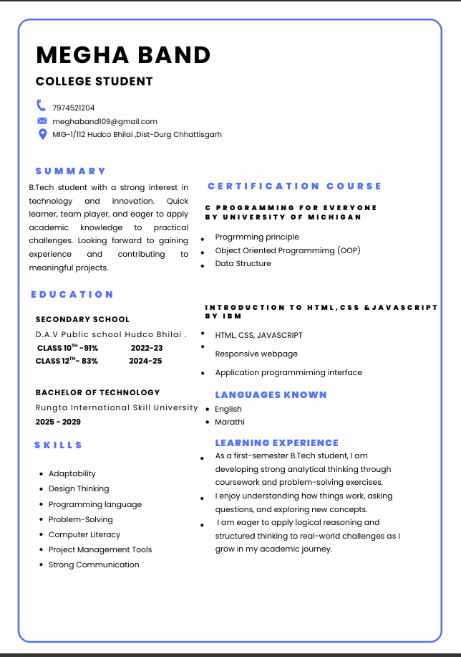

**Practical 2: Career-Oriented Presentation**

**Aim**

To create a career presentation using slides, transitions, and animations.

**Objectives**

• To design a multi-slide professional presentation

• To apply transitions and animations

**Materials Required**

• PowerPoint or Google Slides

**Procedure**

**Open a blank presentation** Launch PowerPoint/Google Slides and select the option to create a new blank presentation.  
 This opens a fresh workspace where you will design your slides.

**Create a title slide** Insert a title slide layout and add the presentation title along with your name or subtitle.  
 Ensure the title is clear, readable, and visually centered on the slide.

**Add minimum 7 slides** Use the “New Slide” option to insert at least seven additional slides with appropriate layouts.  
 Each slide should focus on a single topic or idea for clarity.

**Insert images, icons, and bullet points** Add relevant images and icons to visually support your content.  
 Use bullet points to present information in a structured and easy-to-read format.

**Apply a theme** Choose a professional theme from the design options available in the software.  
 The theme will automatically set consistent fonts, colors, and backgrounds.

**Add transitions and animations** Apply slide transitions for smooth movement between slides.  
 Add animations to text or images to enhance the presentation without overusing effects.



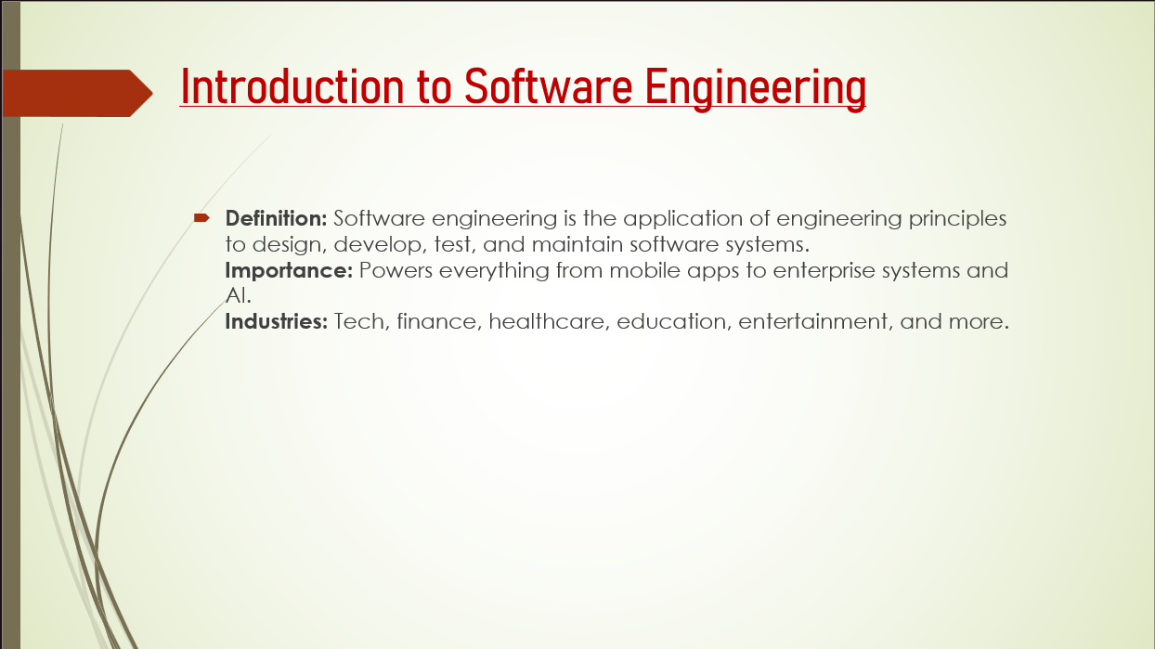

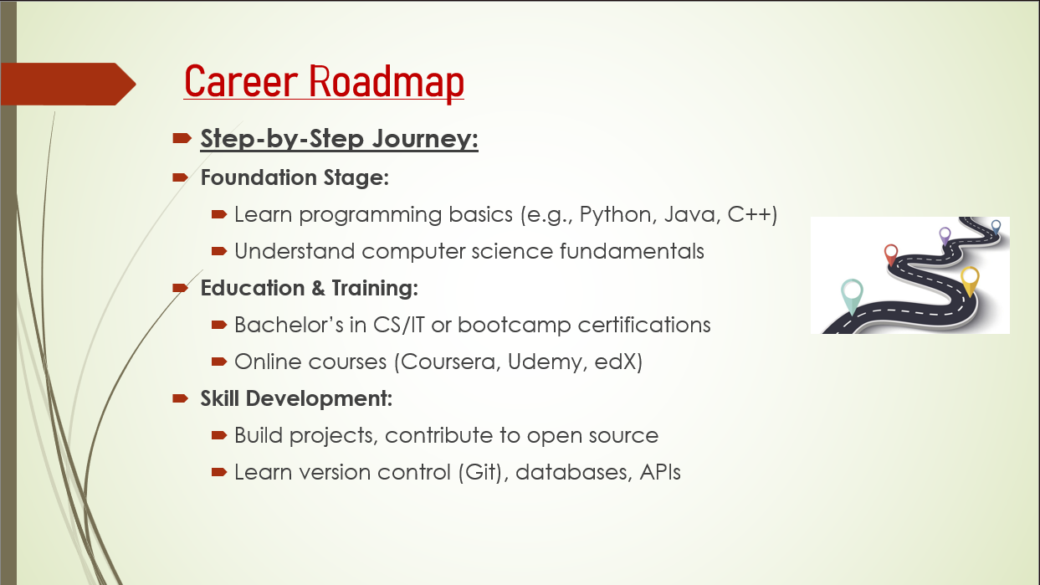

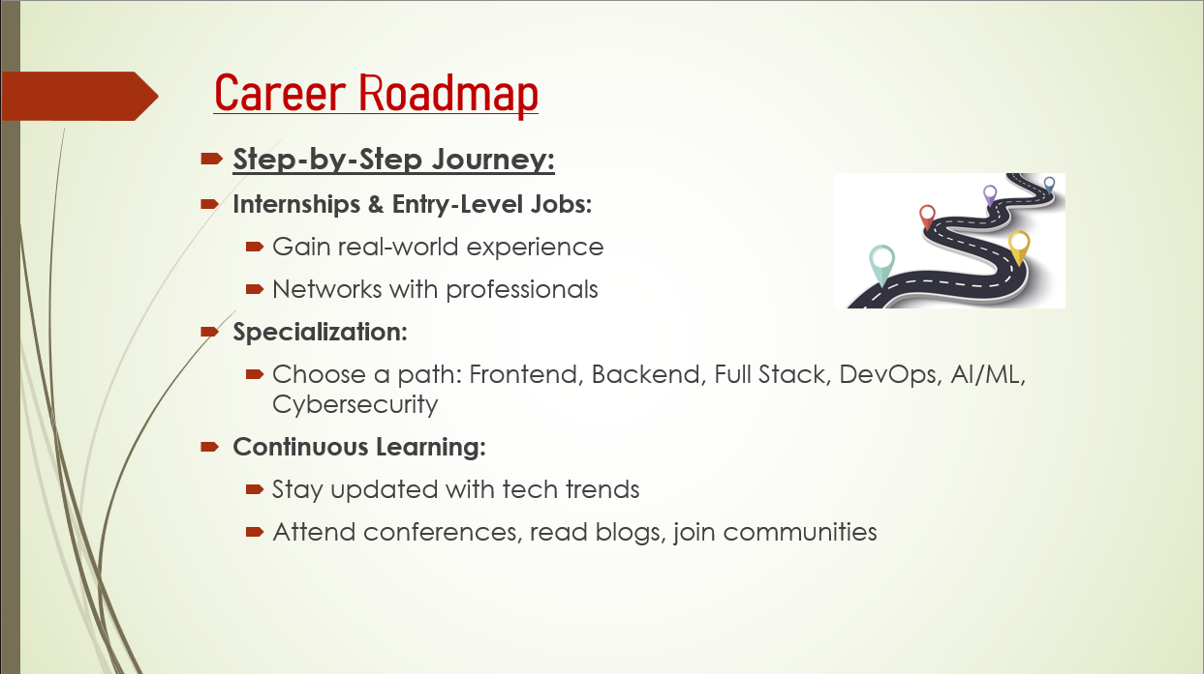

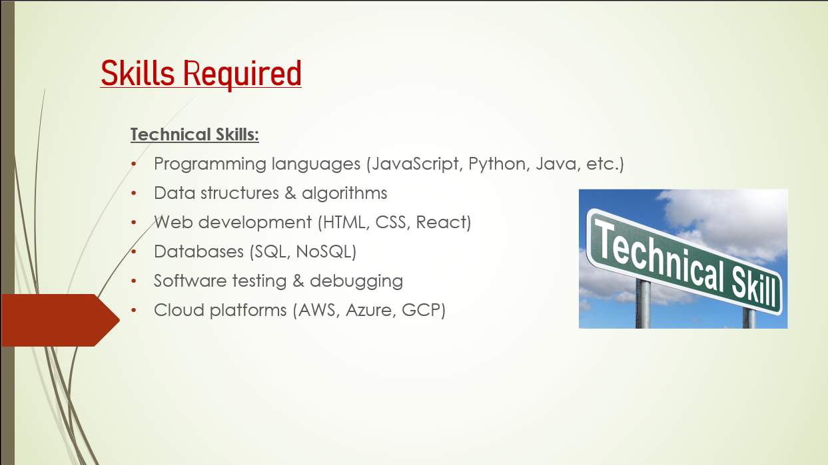

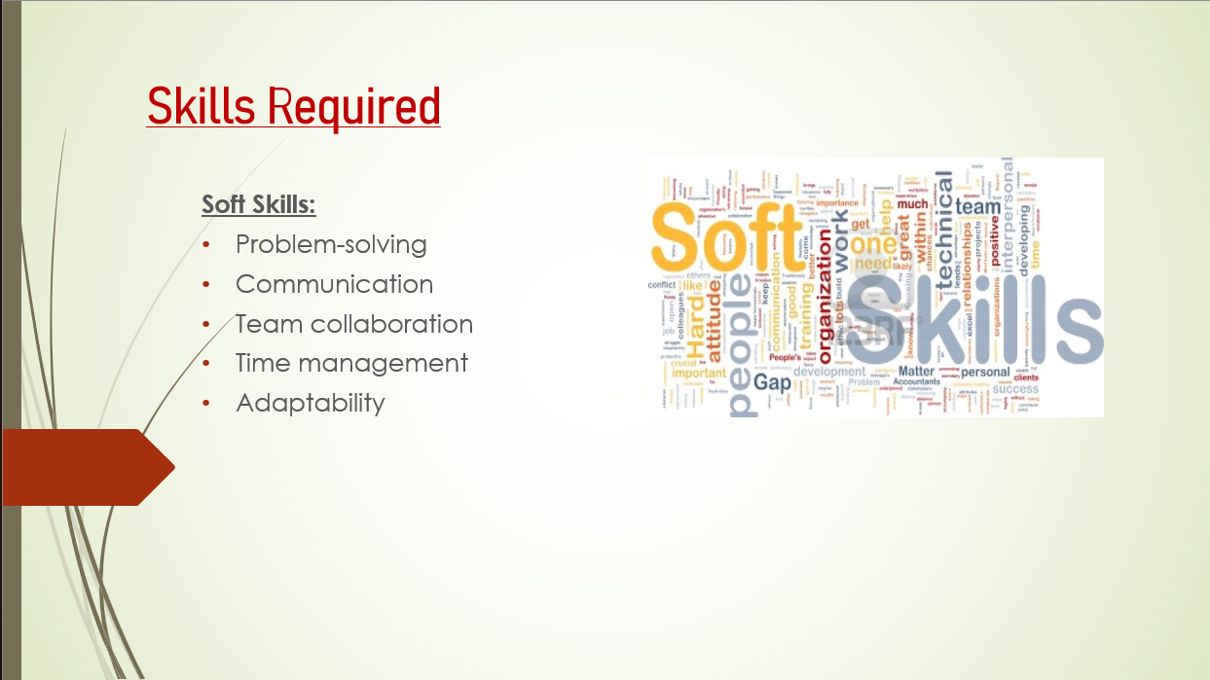

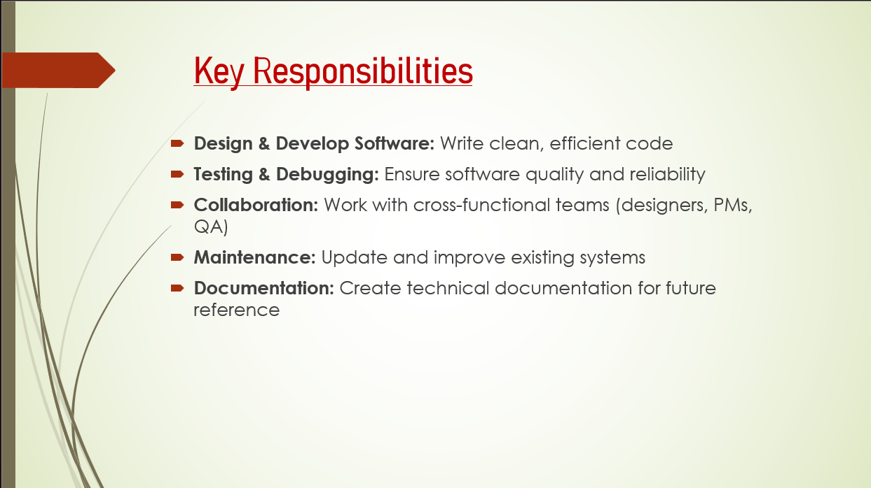

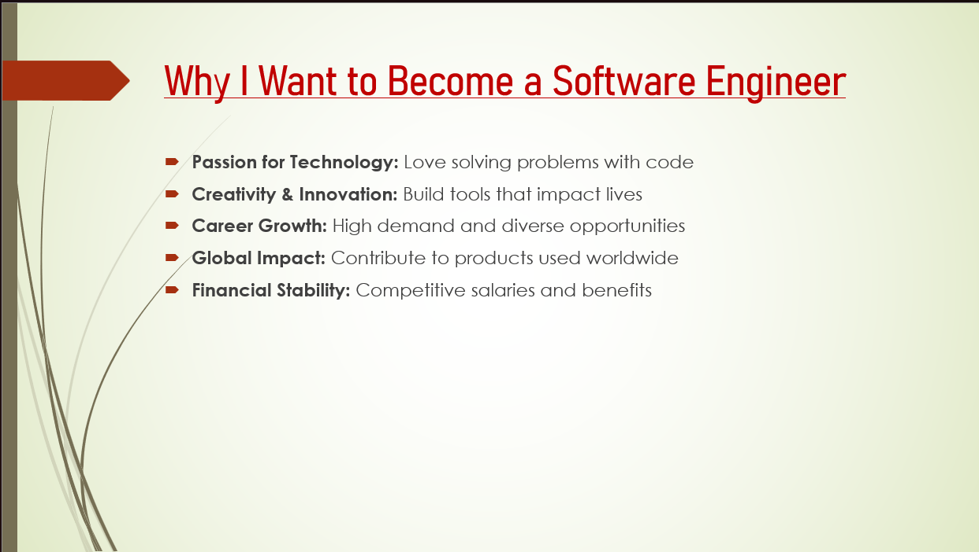



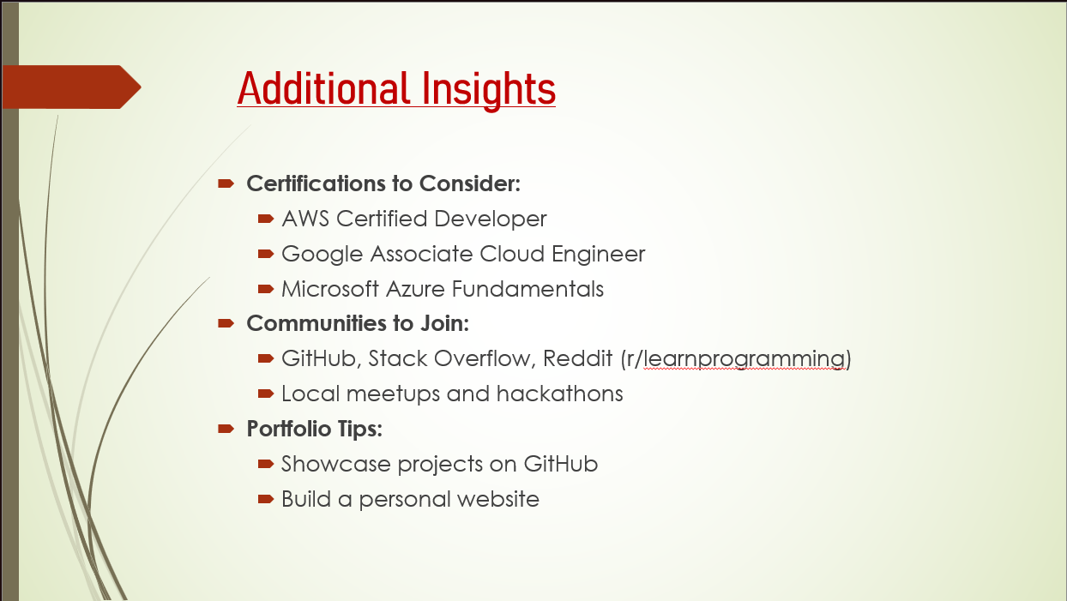

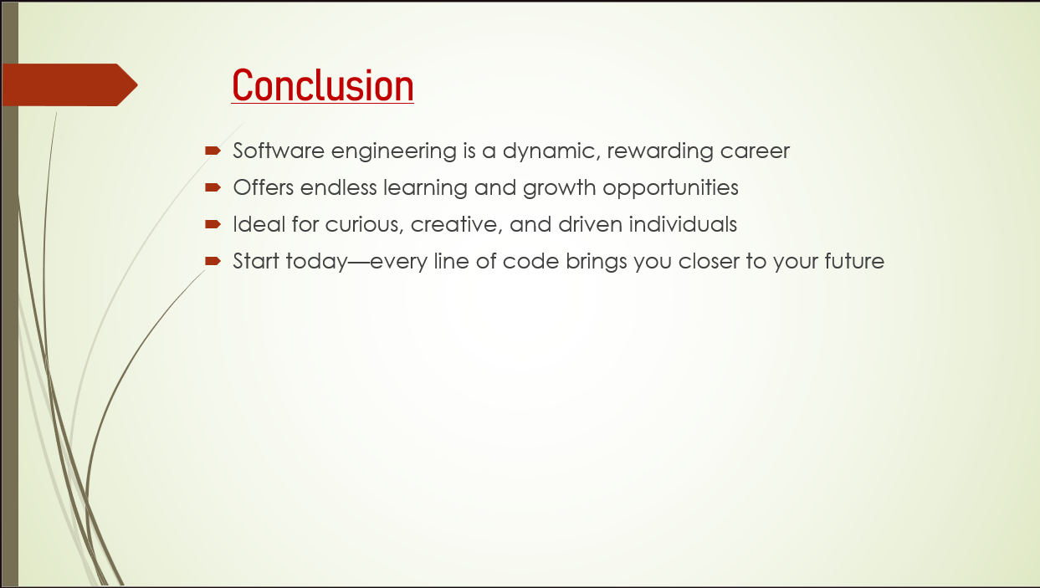



**Practical 3: Digital Awareness Poster in Canva**

**Aim**

To design a poster for Digital Awareness Week using Canva.

**Objectives**

• To apply design tools

• To create a visually appealing poster

**Materials Required**

• Canva account

• Computer with internet

**Procedure**

**Login to Canva** Open Canva in your browser and sign in using your email or Google account.  
 This gives you access to all templates, design tools, and editing features.

**Select poster layout** Search for “Poster” in the template section and choose a suitable layout.  
 This layout provides a ready-made design structure to begin your poster.

**Add “Digital Awareness Week” text** Insert a text box or edit the existing heading and type “Digital Awareness Week.”  
 Adjust the font style, size, and alignment to make the title prominent.

**Insert icons and graphics** Go to the “Elements” tab to add icons, shapes, and relevant graphics.  
 Position them creatively to enhance the visual appeal and message of the poster.

**Apply suitable colors** Choose a color theme that matches the topic and improves readability.  
 Use consistent color combinations for background, text, and elements.

**Download final poster** Click the “Download” button and select the preferred file type, usually PNG or PDF.

Save the poster to your device for printing or sharing

.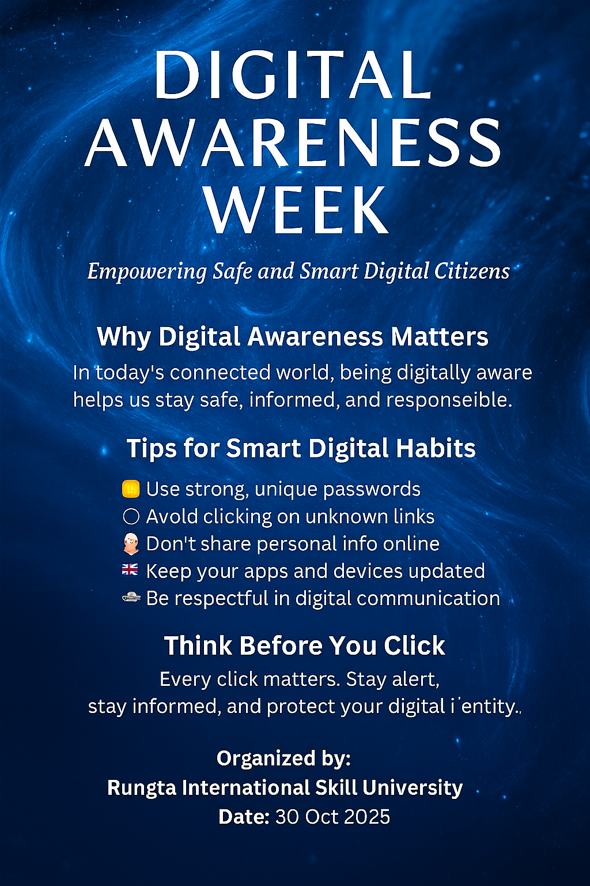

**Practical 4: Professional Email (Internship Application)**

**Aim**

To draft and send a professional internship email with attachment.

**Objectives**

• To compose a professional email

• To attach documents

**Materials Required**

• Email account

• Resume file

**Procedure**

**Open Gmail** Go to the Gmail website or app and log in with your email account.  
 This opens your inbox where you can create and send emails.

**Click Compose** Select the **“Compose”** button to open a new email window.  
 A blank message box will appear on the screen.

**Write subject line** Enter a clear and concise subject that reflects the purpose of the email.  
 This helps the recipient understand the message at a glance.

**Write professional message** Type a polite, well-structured message addressing the recipient formally.  
 Keep the tone respectful and include necessary details or requests.

**Attach resume** Click the **attachment (paperclip)** icon and select your resume file from your device.  
 Ensure the resume is in PDF format and properly named.

**Send email** Review the email for accuracy and ensure attachments are included.  
 Click **“Send”** to deliver the message to the recipient

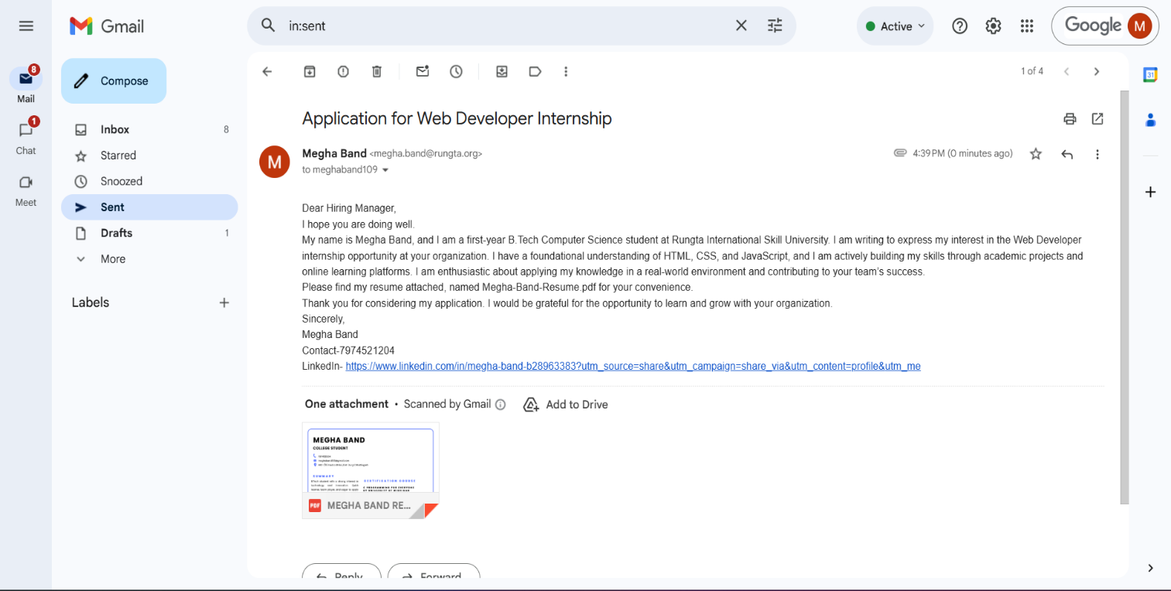

**Practical 5: Create Google Form – Attendance Report**

**Aim**

To design a Google Form and analyze responses.

**Objectives**

• To create form with multiple question types

• To collect sample responses

• To analyze responses

**Materials Required**

• Google account

• Internet

**Procedure**

**Create new Google Form** Open Google Forms from your Google account and click **“Blank Form”** to start a new form.  
 This opens an empty form where you can add questions.

**Title it “Student Attendance Report”** Enter the title at the top of the form and add a short description if needed.  
 This helps respondents understand the purpose of the form.

**Add MCQs, rating, checkbox and short answer** Use the question type menu to insert multiple-choice questions, rating scales, checkboxes, and short-answer fields.  
 Arrange the questions in a logical order for easy response.

**Customize theme** Click the **Theme** icon to change colors, fonts, and header images.  
 This improves the appearance and makes the form visually appealing.

**Share form and collect responses** Use the **Send** button to share the form via link, email, or QR code.  
 Allow participants to submit their responses through any device.

**View summary charts** Go to the **Responses** tab to see automatic charts and graphs generated by Google Forms.  
 These visual summaries help you quickly analyze the collected data.

**Take screenshots** Capture screenshots of the form, responses, and charts for documentation. Save them for use in reports or practical records.

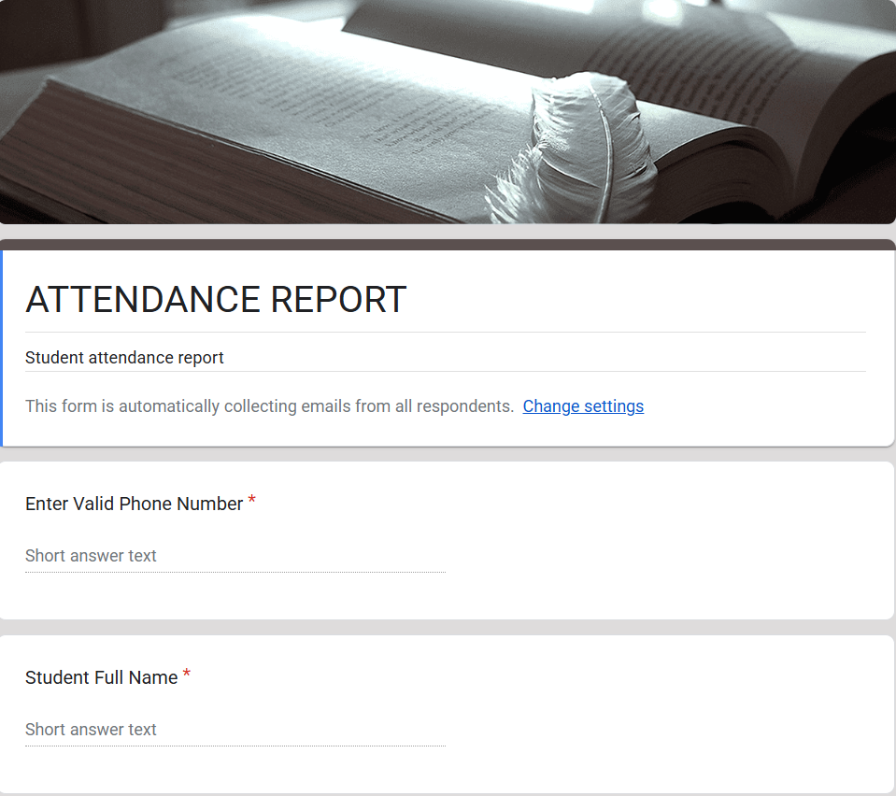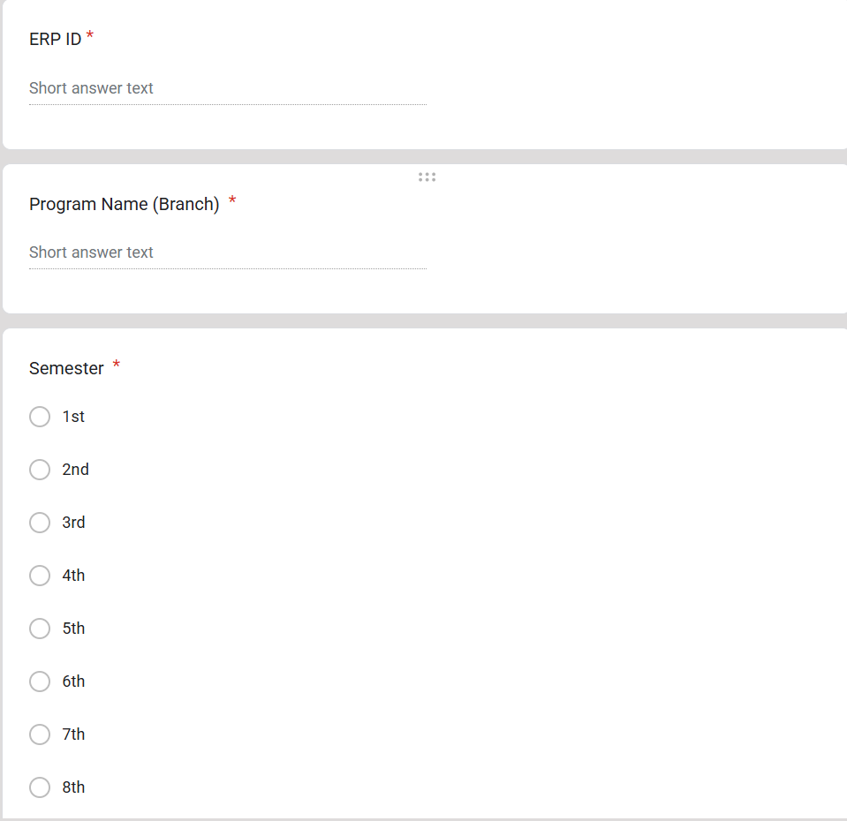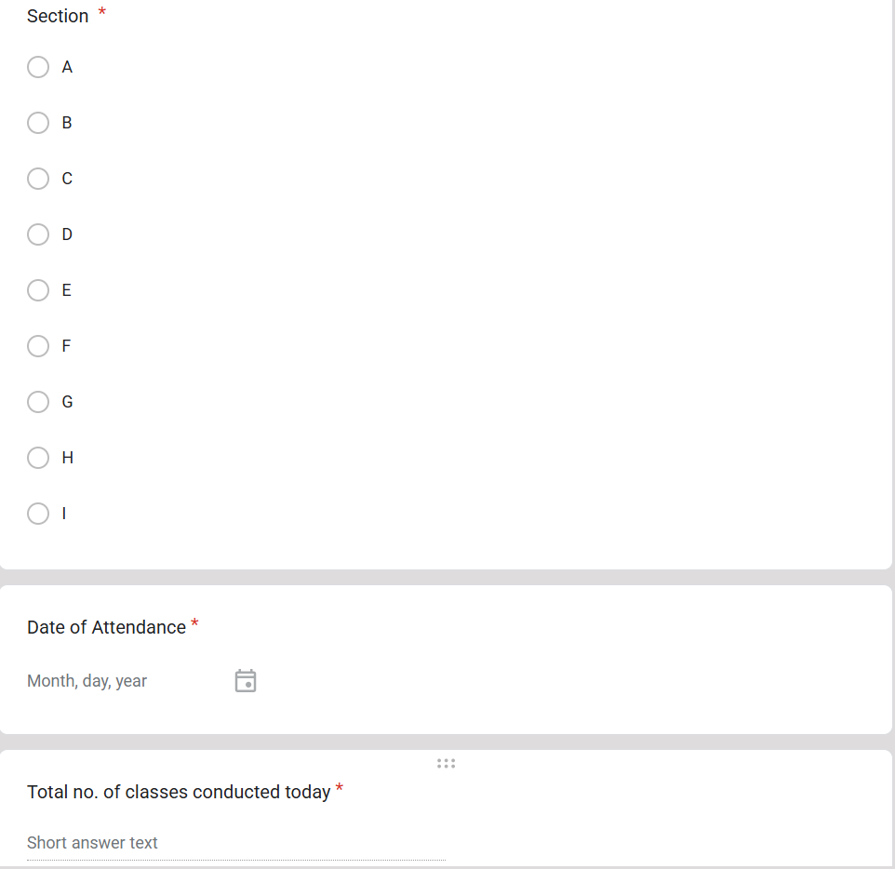

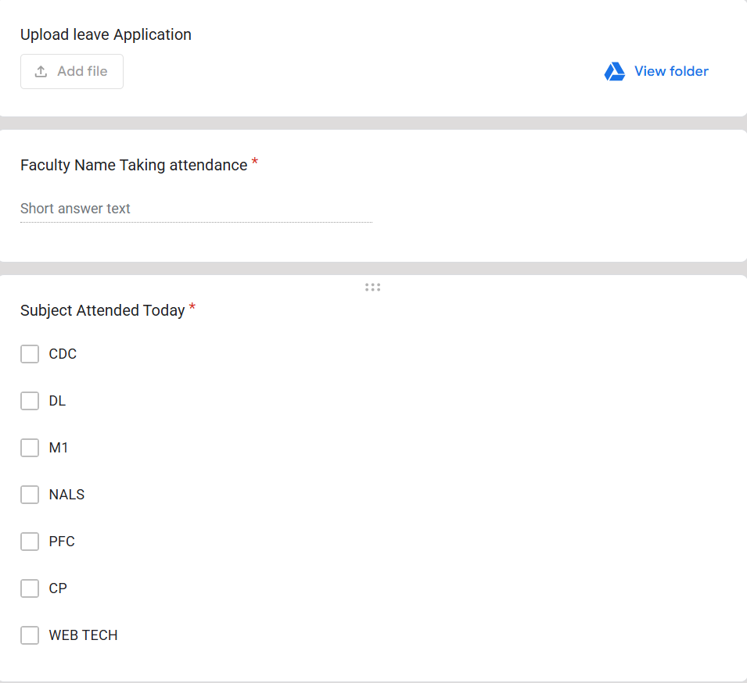

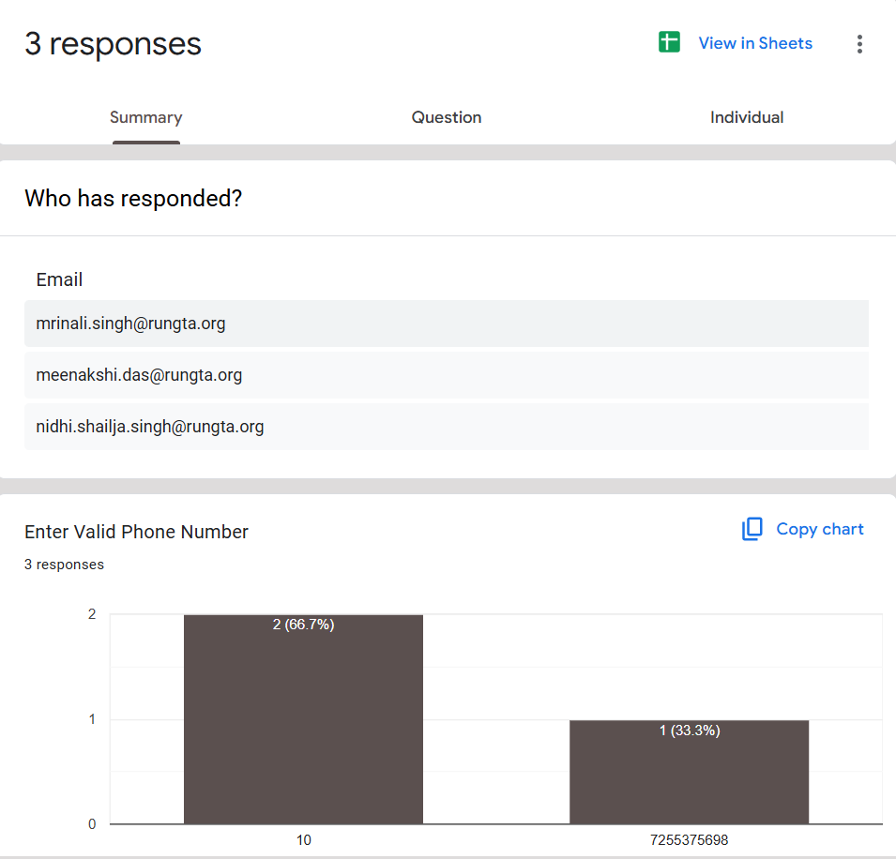

**Practical 6: Create Digital Identity – LinkedIn**

**Aim**

To create and modify digital identity using LinkedIn.

**Objectives**

• To create professional online profile

• To update personal information

**Materials Required**

• LinkedIn account

**Procedure**

**Create LinkedIn profile** Sign up on LinkedIn using your email and set up a new profile.  
 This gives you access to professional networking and career-building tools.

**Add photo, bio, education** Upload a clear professional photo and write a short bio summarizing who you are.  
 Enter your educational details to complete your basic profile information.

**Add skills** Use the “Skills” section to list your technical and soft skills.  
 Adding relevant skills increases your visibility and strengthens your profile.

**Create a simple post** Click “Start a Post” and write a short, meaningful update or introduction.  
 Share it publicly to begin engaging with your professional network.

**Change privacy settings** Go to **Settings & Privacy** to adjust what others can see on your profile.  
 Modify visibility, contact preferences, and data-sharing options as needed.

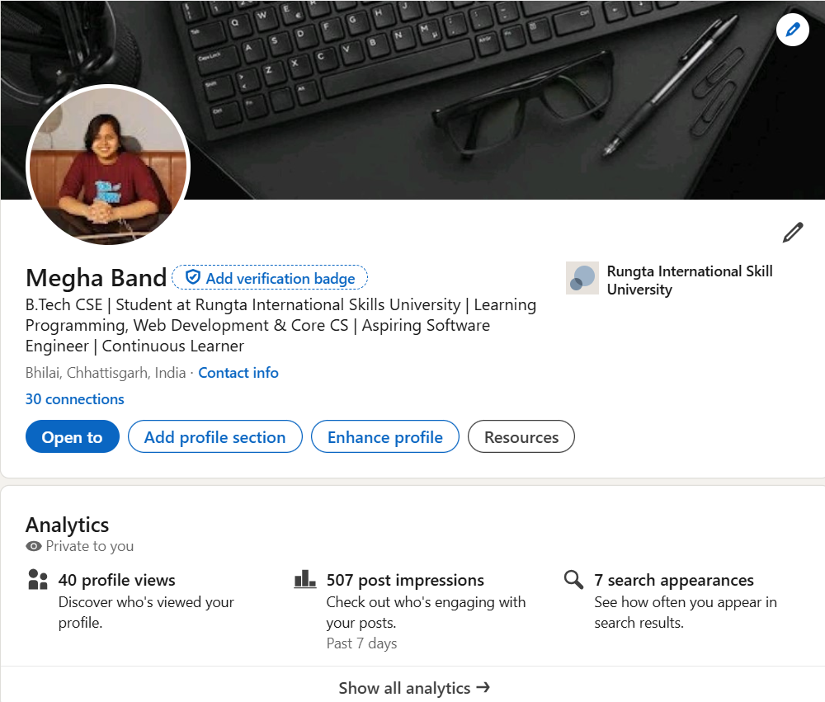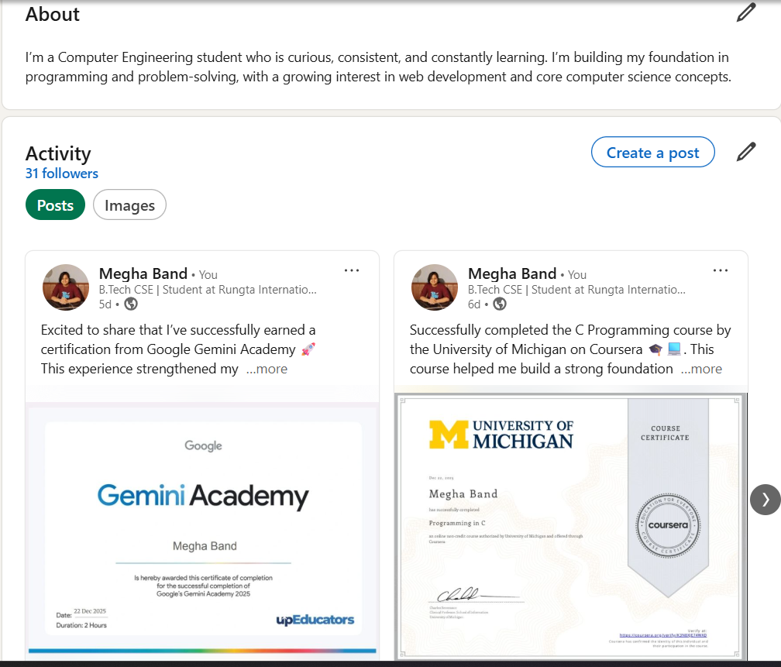

**Practical 7: Using Google Drive / OneDrive**

**Aim**

To upload and organize files in cloud storage.

**Objectives**

• To manage files online

• To share files securely

**Materials Required**

• Google Drive / OneDrive account

**Procedure**

1. **Create folder “Unit 3 Practical Work”** Open Google Drive or your file manager and create a new folder named **“Unit 3 Practical Work.”** This folder will store all files related to the practical.
2. **Upload documents** Click the **Upload** option and select the required documents from your device.  
    The files will be saved inside the main folder for easy access.
3. **Create subfolders** Inside the main folder, create additional subfolders to categorize your documents.  
    This helps keep your work organized and easy to locate.
4. **Share main folder with View only** Right-click the folder, choose **Share**, and set the permission to **View only** for others.  
    This allows people to see the contents but prevents them from editing or deleting files.

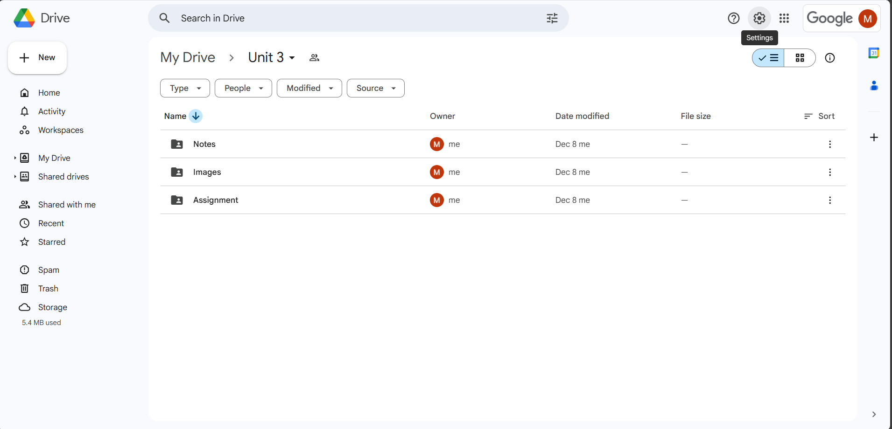

**Practical 8: Identify Phishing Attack**

**Aim**

To identify phishing attempts through digital messages.

**Objectives**

• To detect cybercrime

• To recognize scam elements

**Materials Required**

• Provided phishing example

**Procedure**

**Read message text** Carefully go through the entire message to understand its content and intent.  
 Make note of any unusual requests or unfamiliar senders.

**Identify suspicious elements** Look for spelling errors, urgent demands, unknown links, or too-good-to-be-true offers.  
 These signs often indicate potential scams or malicious intent.

**List cybercrime type** Based on the suspicious elements, categorize the message as phishing, fraud, malware attempt, etc.  
 This helps in understanding the nature and threat level of the cybercrime.

**Write verification steps** Suggest ways to confirm authenticity, such as checking the sender’s email, contacting the official source, or scanning links.  
 These steps help prevent falling victim to cyberattacks.

**“You are shortlisted for a Remote Software Developer role at Google.**

**Salary: ₹18 LPA.**

**Pay ₹2,499 as verification fee.**

**Limited seats. Pay now to confirm.”**

**ANSWER THE QUESTION :-**

1. **What type of cybercrime is happening here?**

This is a Job Recruitment Scam. In this cybercrime fraudsters pretend to be a reputed company like Google and send fake job offers. They attract people with a high salary and then ask for money in the name of verification fees. The main intention is to cheat people and take their money.

1. **List** 3 red flags **that show it is a scam?**

* Asking for a “verification fee” – Legitimate companies like Google never ask candidates to pay money.
* Too-good-to-be-true offer – High salary (₹18 LPA) with quick selection and “limited seats.”
* Urgency pressure – “Pay now to confirm” is used to stop people from thinking carefully.

**c. What should he do to verify if a job offer is real?**

• Check the offer on the official company website or career portal.

• Verify the email domain (real Google emails end with @google.com).

• Contact the company through official HR channels or LinkedIn.

• Never pay any fee for job verification or selection

**Practical 9: Google Form Quiz with Timer**

**Aim**

To create a quiz with automatic grading and time limit.

**Objectives**

• To automate quiz assessment

• To use time limit add-on

**Materials Required**

• Google Forms

• Timer add-on

**Procedure**

1. Create Google Form – Open Google Forms and start a new blank form to set up the structure of your activity.

2. Convert to quiz – Enable “Make this a quiz” in the settings so you can assign points and correct answers.

3. Add 5 MCQs + 1 short answer – Insert five multiple-choice questions and one short-answer question, customizing options and points.

4. Enable 1-response limit – Turn on “Limit to 1 response” so each user can submit the form only once.

5. Shuffle questions – Activate the shuffle feature to randomize the order of questions for every respondent.

6. Add timer add-on – Install a timer add-on from the Add-ons menu to set and control the quiz duration.

7. Send link – Use the “Send” button to generate and share the form link with participants.

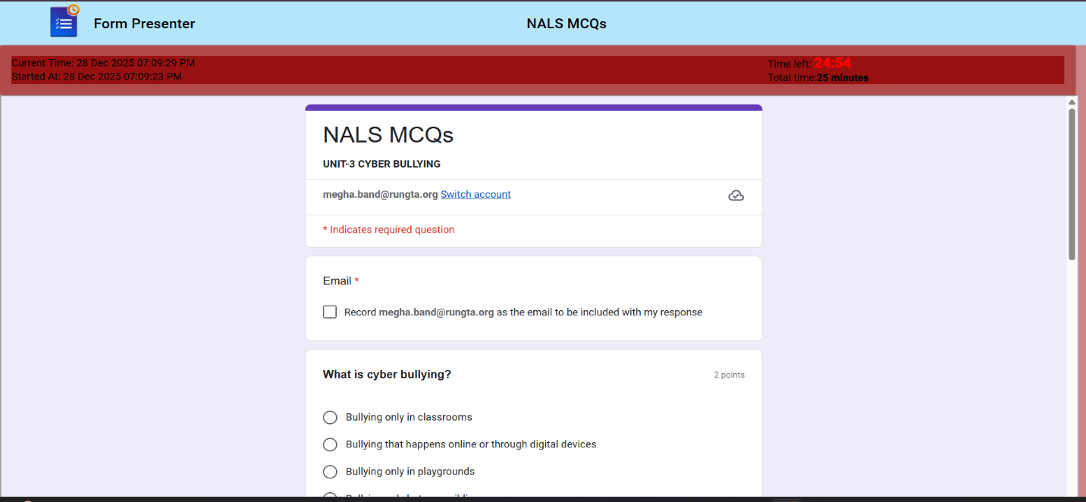

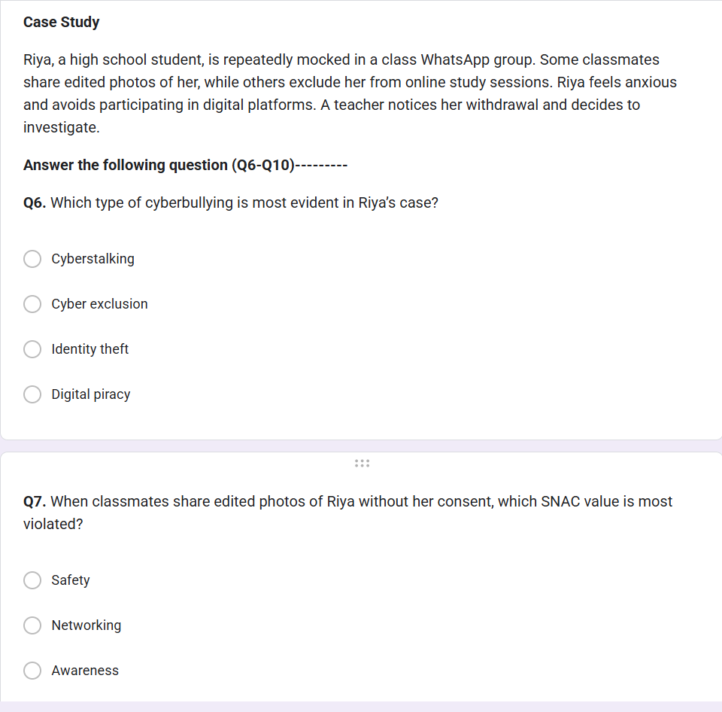

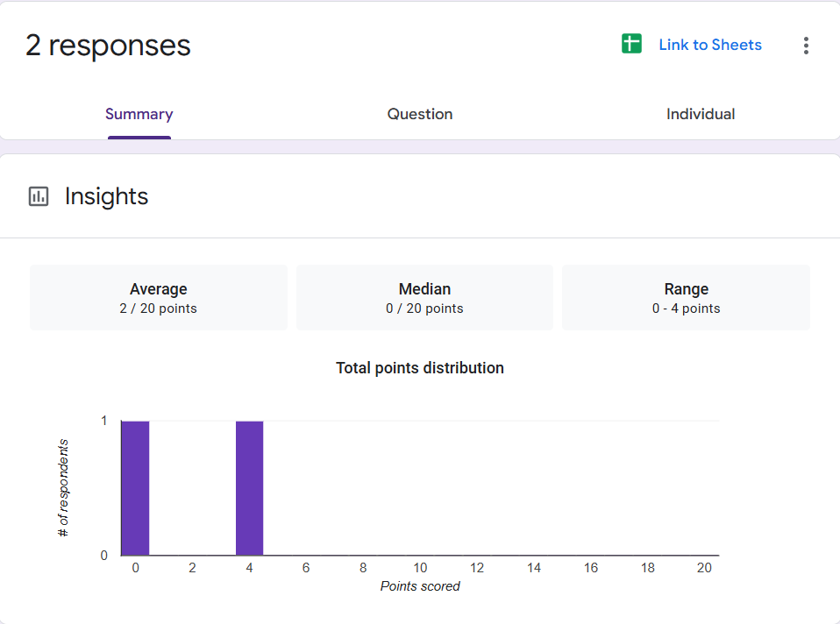**Practical 10: AI Text Bias & Plagiarism**

**Aim**

To analyze AI generated text for plagiarism and bias.

**Objectives**

• To detect biased statements

• To improve writing

**Materials Required**

• ChatGPT / Gemini

• Grammarly

**Procedure**

1. Generate paragraph from AI – Use an AI writing tool to produce a clear, coherent paragraph on your chosen topic.

2. Check plagiarism – Run the paragraph through a plagiarism checker to ensure originality and proper attribution.

3. Check grammar – Review the text with a grammar tool to correct errors in punctuation, spelling, and sentence structure.

4. Identify biased statements – Examine the content for subjective language, assumptions, or one-sided viewpoints.

5. Rewrite neutrally – Revise the paragraph to remove bias, ensuring the tone is balanced, objective, and fact-based.

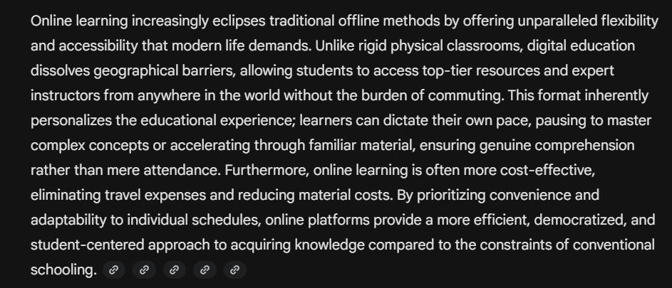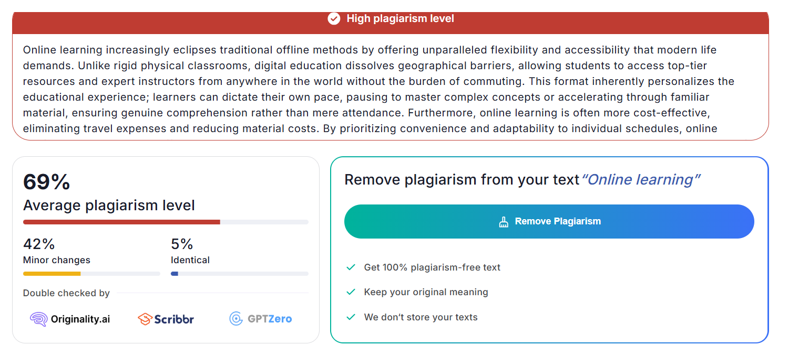

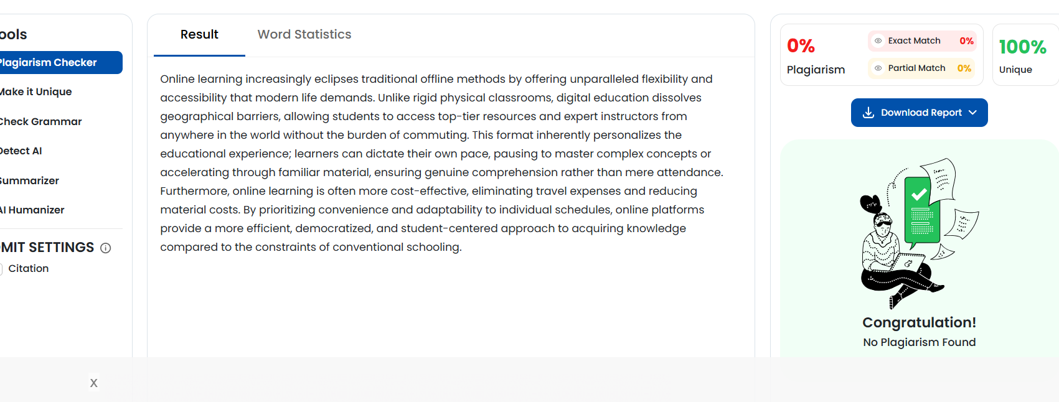

**Practical 11: Compare AI vs Human Writing**

**Aim**

To compare AI-generated content with student-created content.

**Objectives**

• To identify difference in writing

• To understand AI limitations

**Materials Required**

• AI tool

**Procedure**

1. Write paragraph manually – Compose a paragraph yourself using your own ideas, wording, and structure on the selected topic.

2. Generate same topic using AI – Use an AI tool to produce another paragraph on the same topic for comparison.

3. Create comparison table – Organize both paragraphs side-by-side in a table to compare style, clarity, tone, and content differences.

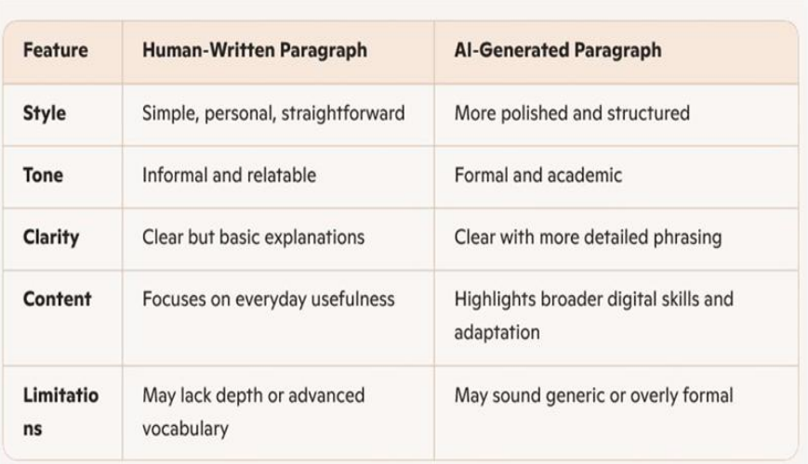

**Practical 12: NotebookLM Project**

**Aim**

To create revision notes using NotebookLM.

**Objectives**

• To generate study guide

• To create flashcards

**Materials Required**

• NotebookLM

**Procedure**

1. Create NotebookLM project – Start a new project in NotebookLM to organize your materials and AI-generated outputs in one workspace.

2. Upload two resources – Add two documents or sources to the project so the AI can analyze and reference them.

3. Generate study guide – Use NotebookLM’s tools to create a structured study guide summarizing key concepts from the uploaded resources.

4. Generate flashcards – Automatically produce flashcards that highlight important facts, terms, or ideas for easier review.

5. Review accuracy – Carefully check the summaries and flashcards to ensure all information is correct and reflects the original resources.

6. Take screenshots – Capture screenshots of the study guide and flashcards to document your work or include them in your submission.

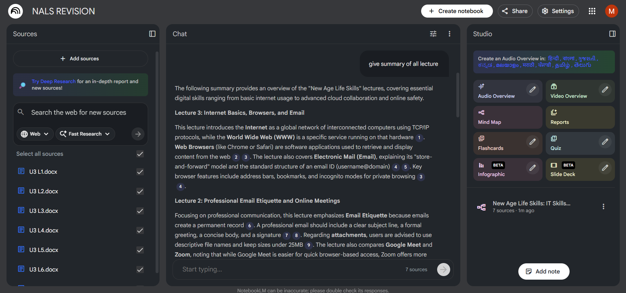

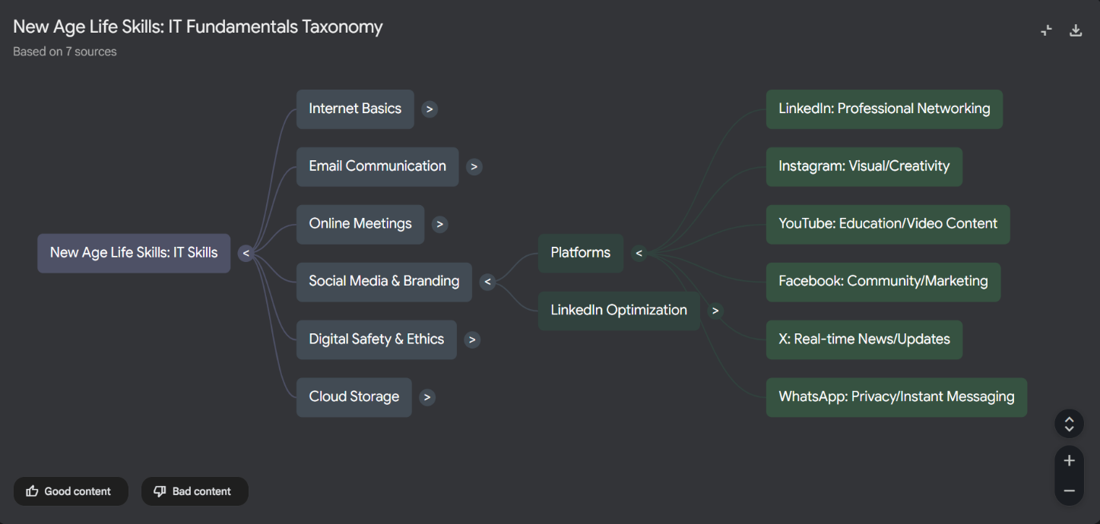

**Practical 13: Excel Student Result Management**

**Aim**

To analyze student marks using Excel tools.

**Objectives**

• To apply Excel formulas

• To create charts

**Materials Required**

• MS Excel

**Procedure**

1. Enter student data – Input students’ names, marks, and other required details into the spreadsheet.

2. Use Flash Fill – Apply Flash Fill to automatically complete patterns such as separating names or formatting data.

3. Replace incorrect values – Identify errors and use Find & Replace or manual correction to fix inaccurate entries.

4. Calculate pass/fail using IF – Create an IF formula to determine whether each student passes or fails based on their score.

5. Use COUNTIF and AVERAGE – Apply COUNTIF to count specific results and AVERAGE to compute the class’s mean score.

6. Create charts – Generate visual charts to represent student performance trends or score distributions.

7. Apply conditional formatting – Use color-based formatting to highlight important values, such as low scores or top performers.

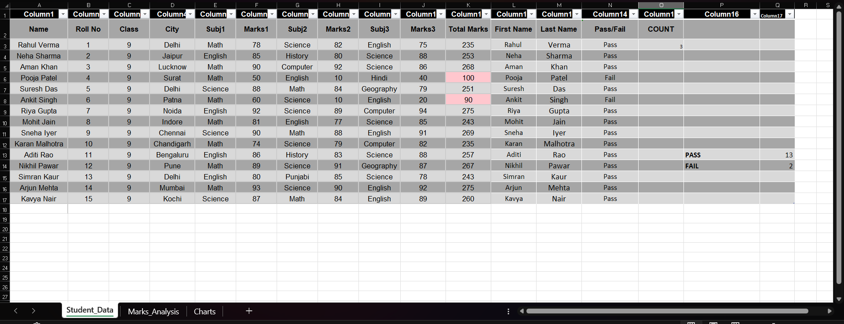

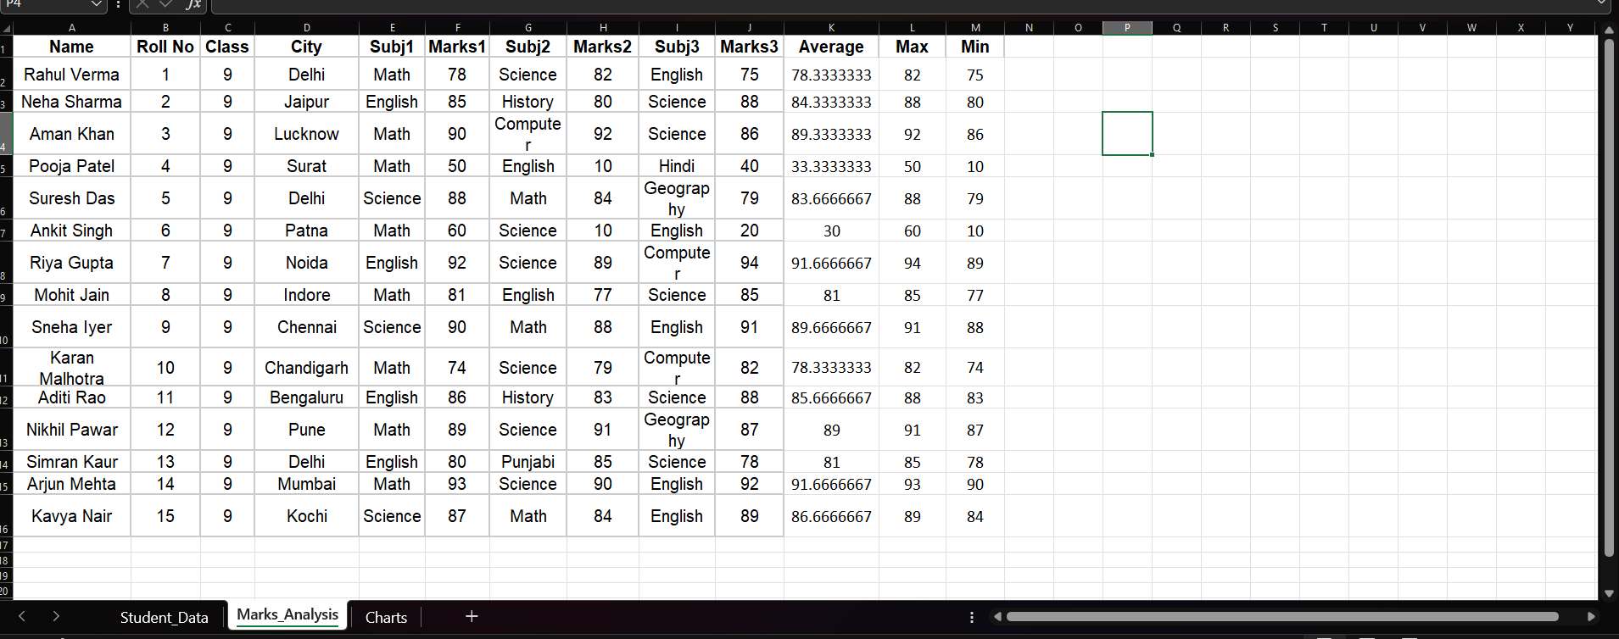

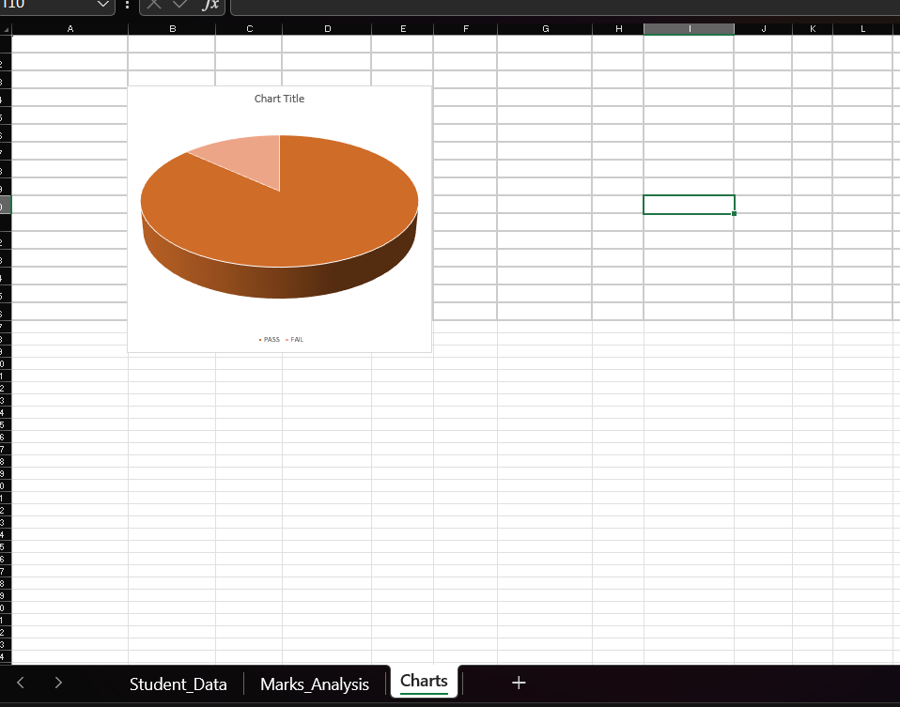

**Practical 14: Sales Data Workbook**

**Aim**

To analyze sales data using Excel formulas and charts.

**Objectives**

• To use SUMIF formulas

• To filter categories

**Materials Required**

• Excel

**Procedure**

1. Enter or import sales data – Add sales records manually or import them from an external file to build your dataset.

2. Sort and filter – Organize the data by sorting and apply filters to focus on specific products, dates, or regions.

3. Use SUMIF – Apply the SUMIF function to total sales based on a chosen condition, such as product type or salesperson.

4. Extract text using LEFT/RIGHT – Use LEFT or RIGHT functions to pull specific characters from product codes or IDs.

5. Create line chart – Plot a line chart to visualize sales trends over time for clearer analysis.

6. Protect sheet – Lock the sheet or specific cells to prevent unauthorized edits and maintain data integrity.

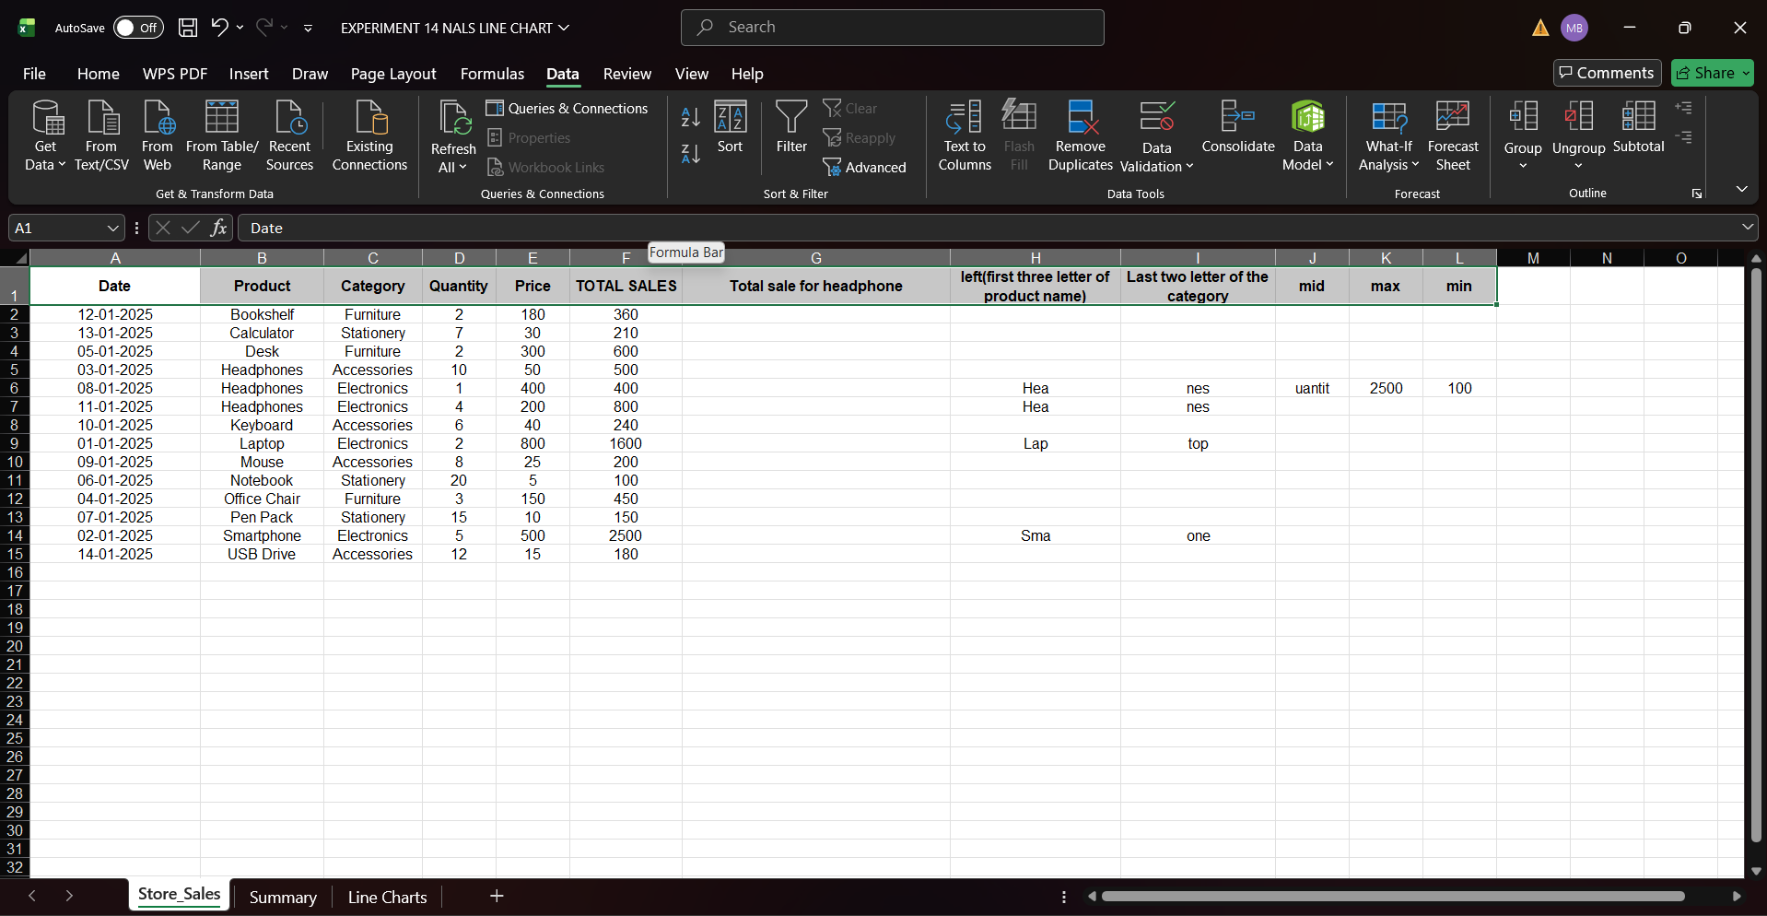

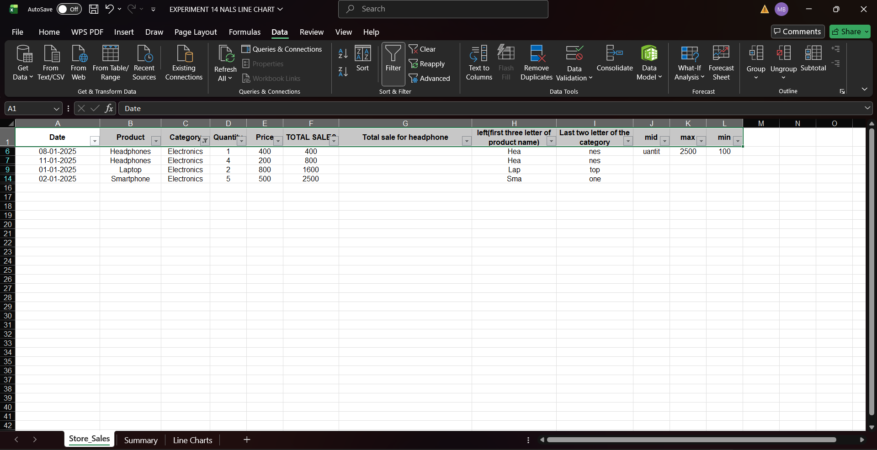

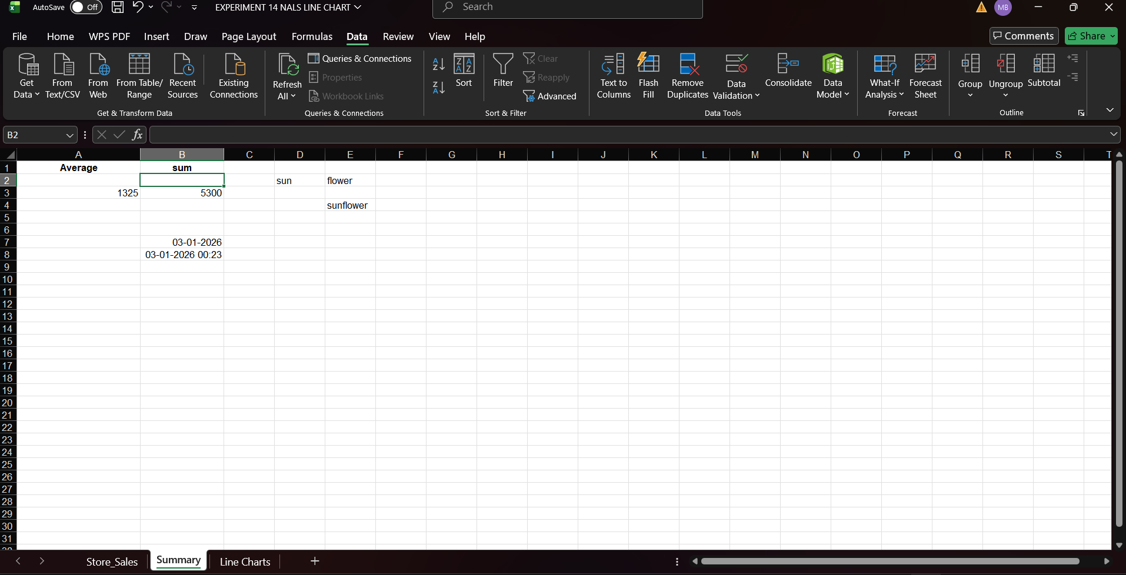

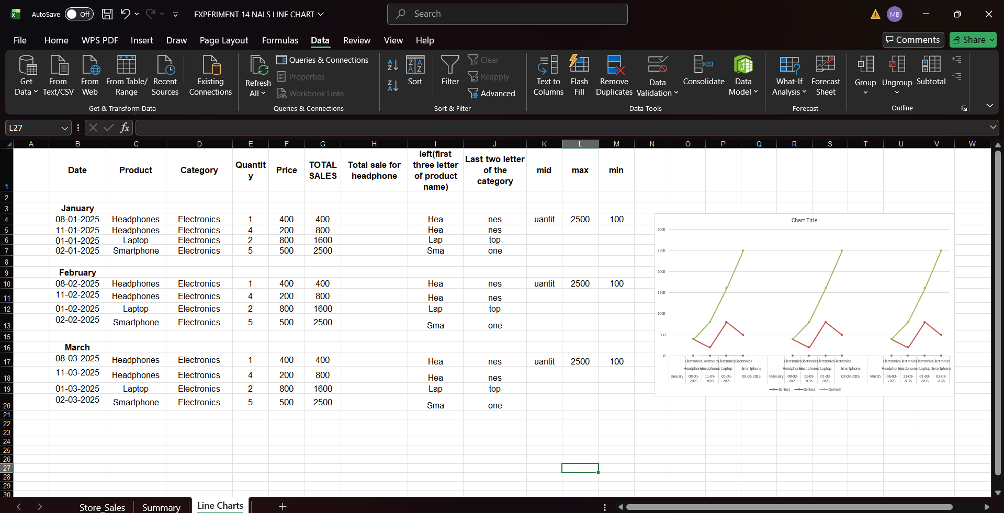

**Practical 15:** **Personal Financial Planner**

**Aim**

To prepare a personal financial planner using Excel.

**Objectives**

• To track expenses

• To compare budget vs actual

**Materials Required**

• Excel

**Procedure**

1. Enter expenses – Record all expense items with their categories, dates, and amounts in the spreadsheet.

2. Apply Data Validation – Set validation rules to restrict inputs, such as allowing only numbers or predefined categories.

3. Use SUMIF – Use the SUMIF function to total expenses by category or any specific condition you choose.

4. Create budget sheet – Design a separate sheet comparing planned budgets to actual spending for better tracking.

5. Highlight expenses above limit – Apply conditional formatting to automatically mark entries that exceed your budget limit.

6. Create charts – Generate charts to visually present spending patterns, category breakdowns, or monthly totals.

7. Adjust print settings – Modify page layout, scaling, and margins to ensure the sheet prints clearly and fits on the page.

